

**Batch: B-4** **Roll No.: 16010422234 Name: Chandana Ramesh Galgali**

**Experiment No.:7**

**Aim:** Torun Data Warehouse simulation

___________________________________________________________________________

**Resources needed: Different RDBMS such as MySQL, Postgres**

**___________________________________________________________________________**

**Theory**

**Data Warehouse :**

A data warehouse is a type of data management system that is designed to enable and support business intelligence (BI) activities, especially analytics. Data warehouses are solely intended to perform queries and analysis and often contain large amounts of historical data. The data within a data warehouse is usually derived from a wide range of sources such as application log files and transaction applications.

A data warehouse centralizes and consolidates large amounts of data from multiple sources. Its analytical capabilities allow organizations to derive valuable business insights from their data to improve decision-making. Over time, it builds a historical record that can be invaluable to data scientists and business analysts. Because of these capabilities, a data warehouse can be considered an organization’s “single source of truth**.**

**ETL :**

Extract, Transform, Load (ETL) refers to a process in database usage and especially in data warehousing. Data extraction is where data is extracted from homogeneous or heterogeneous data sources; data transformation where the data is transformed for storing in the proper format or structure for the purposes of querying and analysis; data loading where the data is loaded into the final target database, more specifically, an operational data store, data mart, or data warehouse.

By using an established ETL framework, one may increase one's chances of ending up with better connectivity and scalability. A good ETL tool must be able to communicate with the many different relational databases and read the various file formats used throughout an organization. ETL tools have started to migrate into Enterprise Application Integration, or even Enterprise Service Bus, systems that now cover much more than just the extraction, transformation, and loading of data. A common use case for ETL tools include converting CSV files to formats readable by relational databases. A typical translation of millions of records is facilitated by ETL tools that enable users to input csv-like data feeds/files and import it into a database with as little code as possible. ETL tools in most cases contain a GUI that helps users conveniently transform data, using a visual data mapper, as opposed to writing large programs to parse files and modify data types.

**__________________________________________________________________________**

**Activities:**

**For Data Warehouse:**

1. Visit <https://www.oracle.com/webfolder/s/assets/demo/adw-quicktour-na/index.html#step1>
2. Go through the demo of Autonomous Data Warehouse for different businesses
3. Prepare a report with following points
   1. The nature of analytics for different businesses given
   2. Comparison between traditional analysis and analysis with Data Warehouse
   3. For any two business type given, specify at least two different scenarios where the tool can be useful

**________________________________________________________________________**

**Results:**

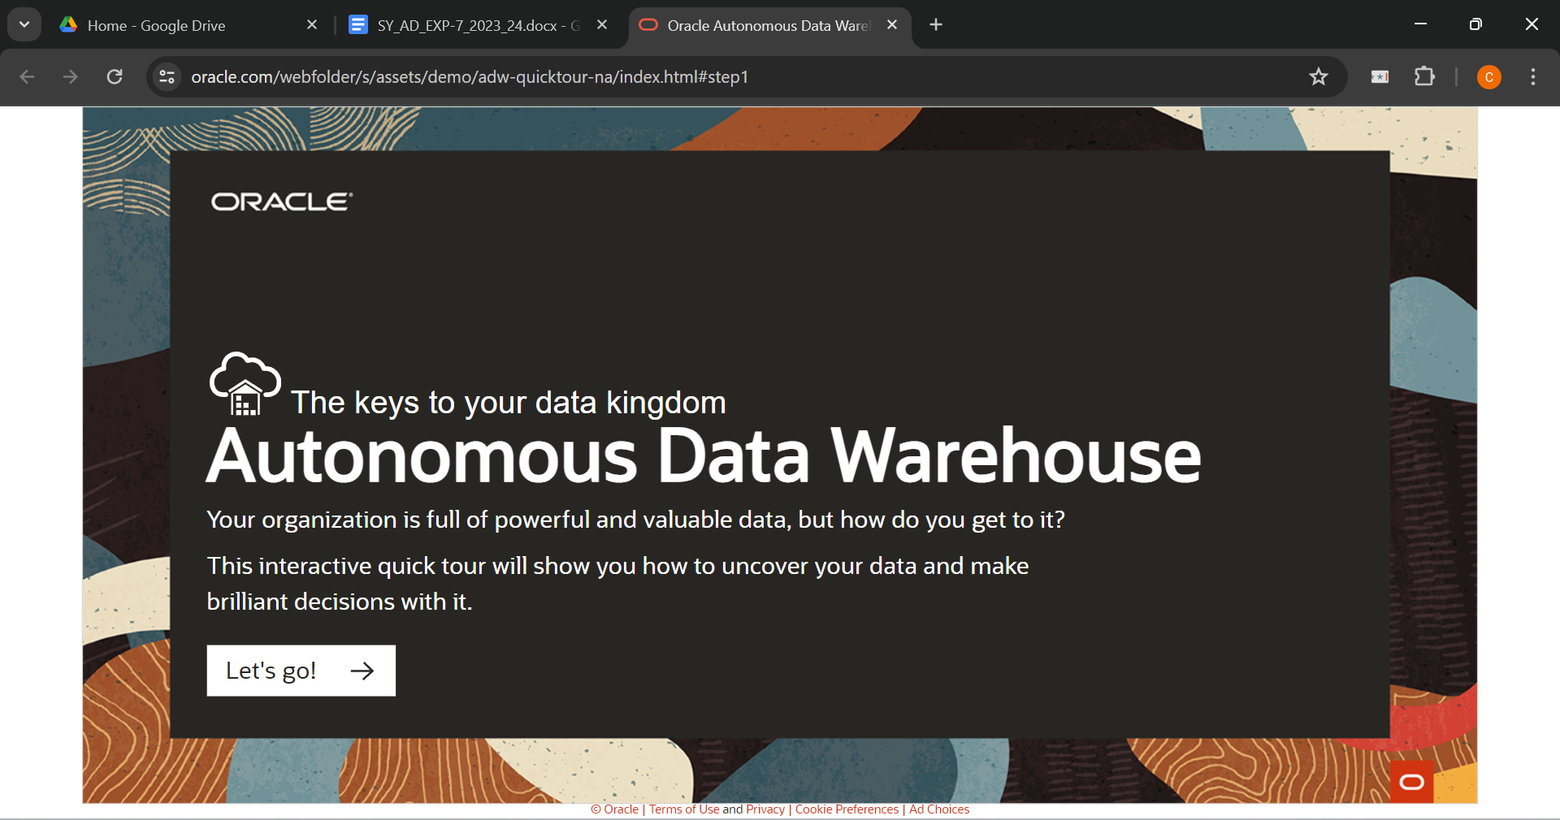

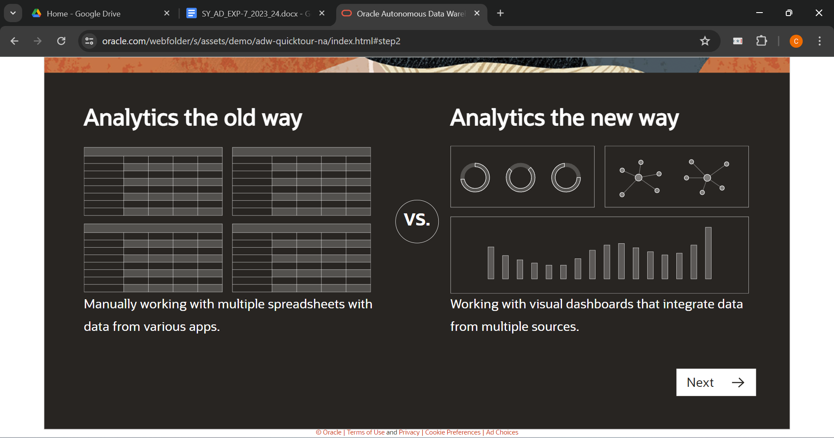

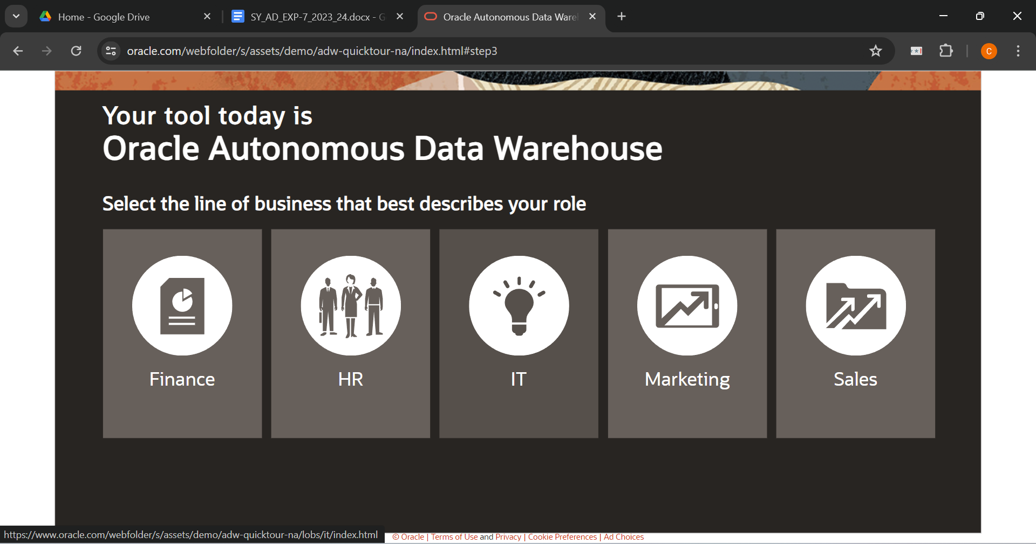

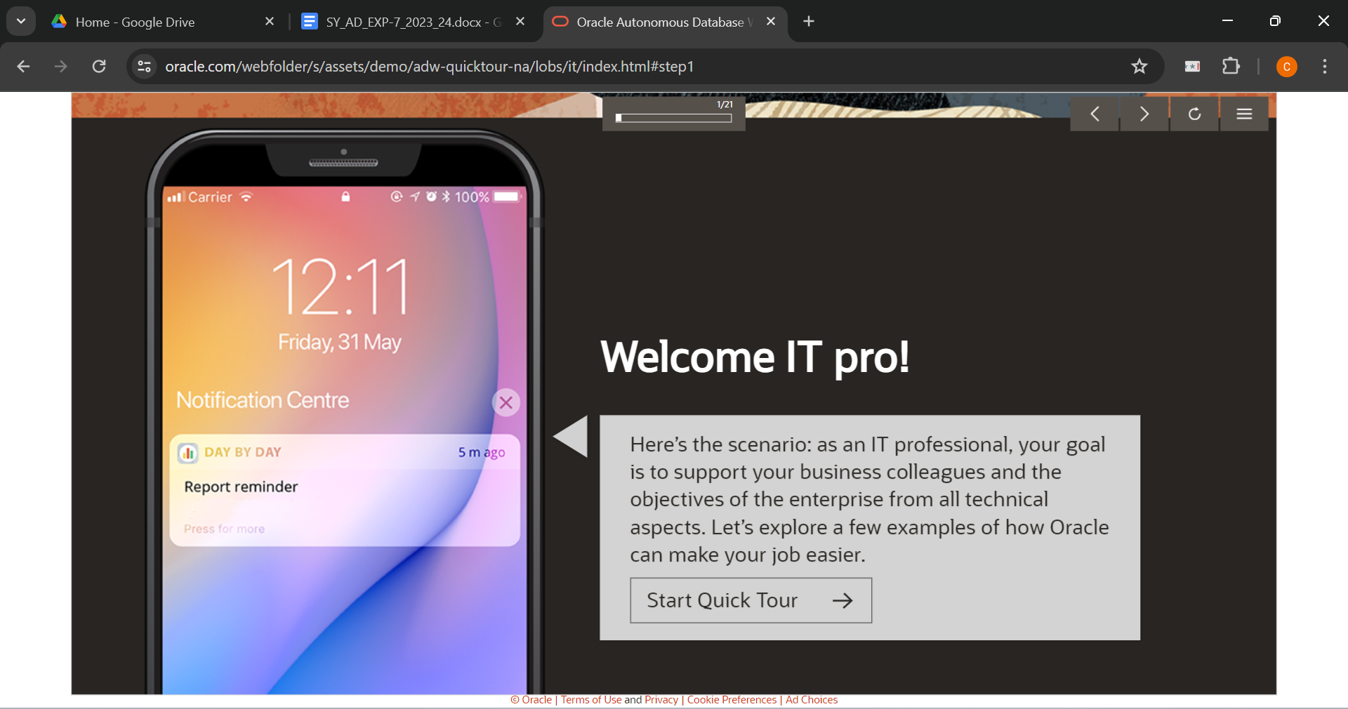

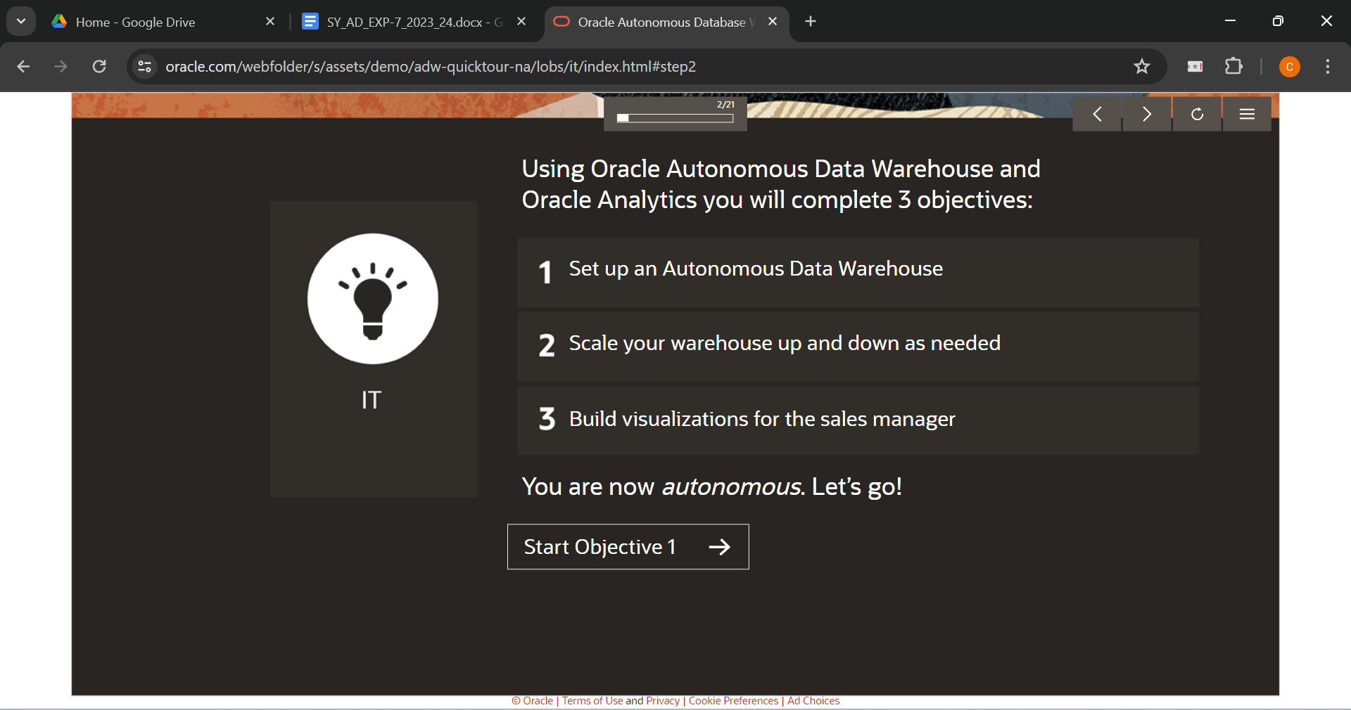

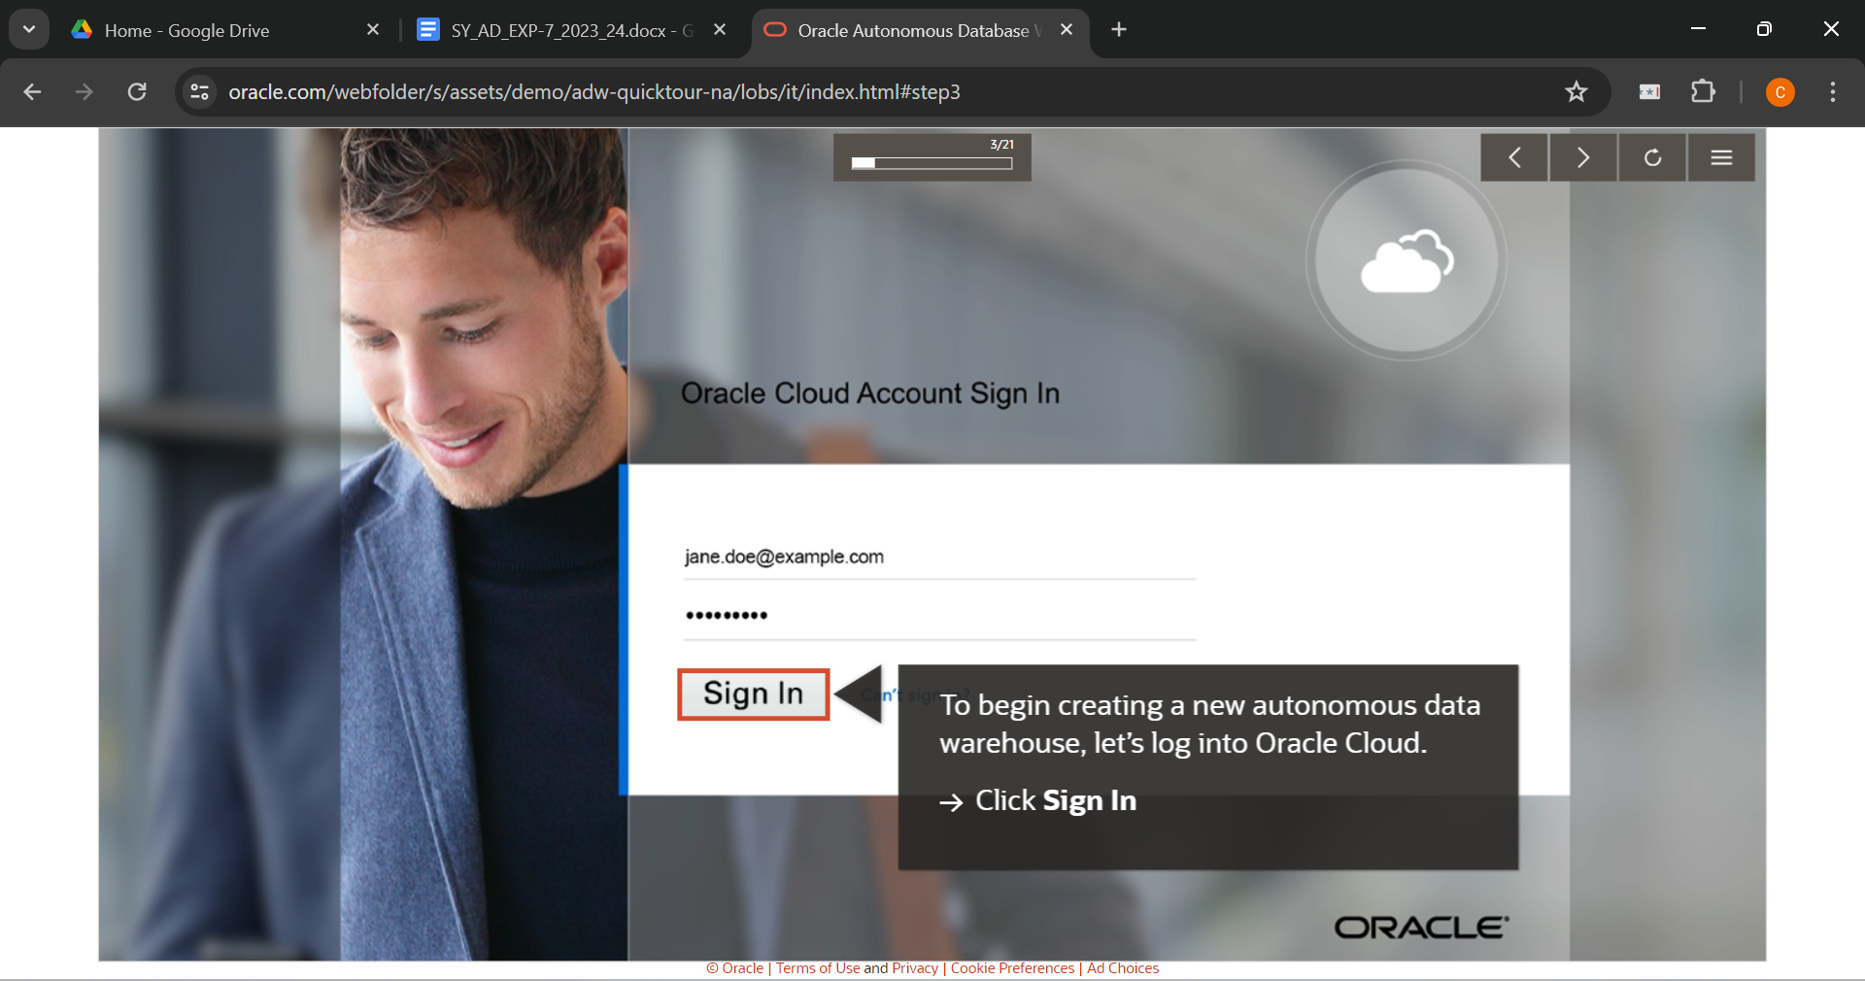

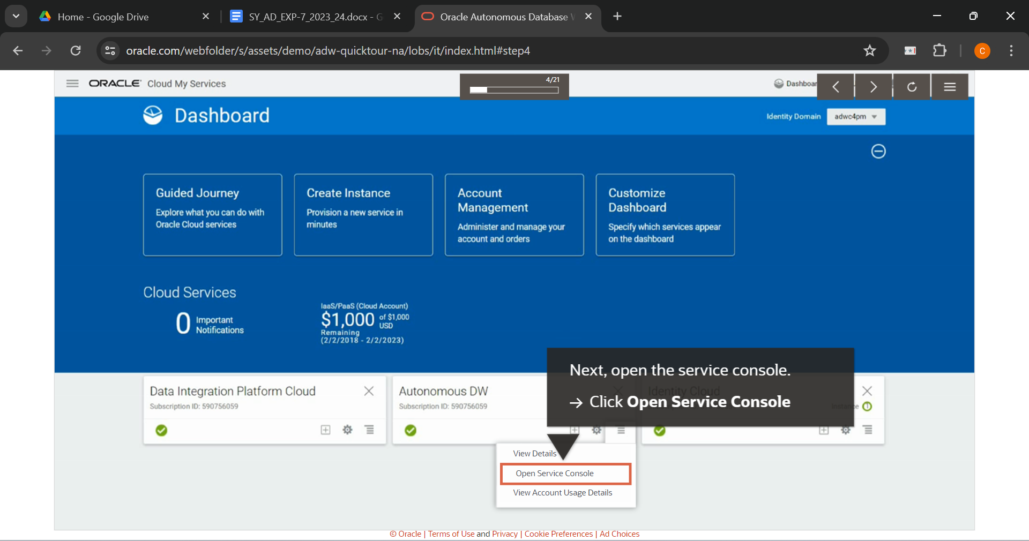

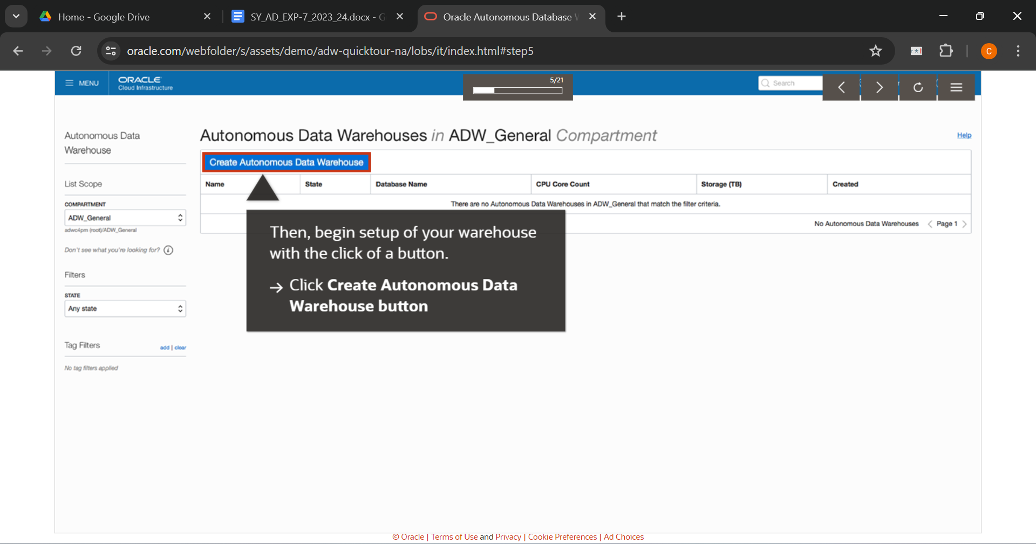

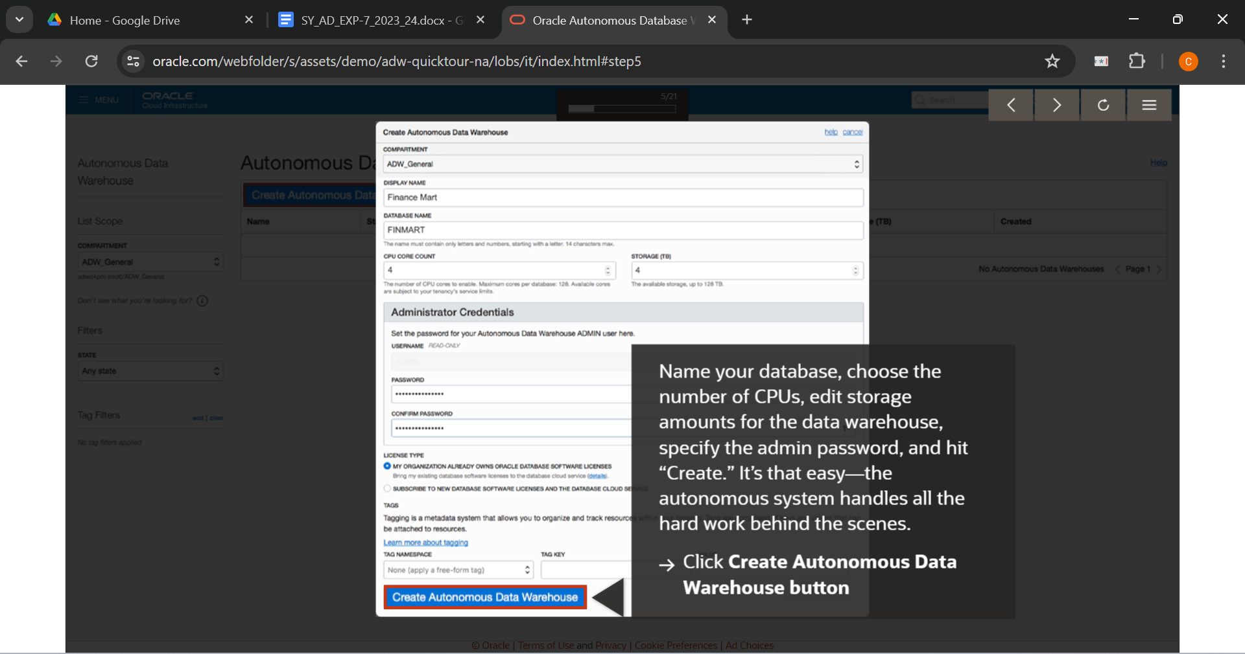

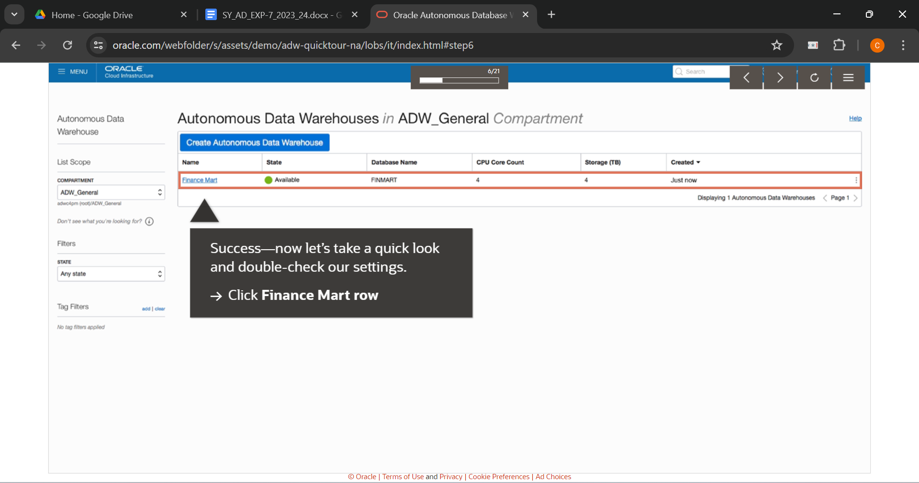

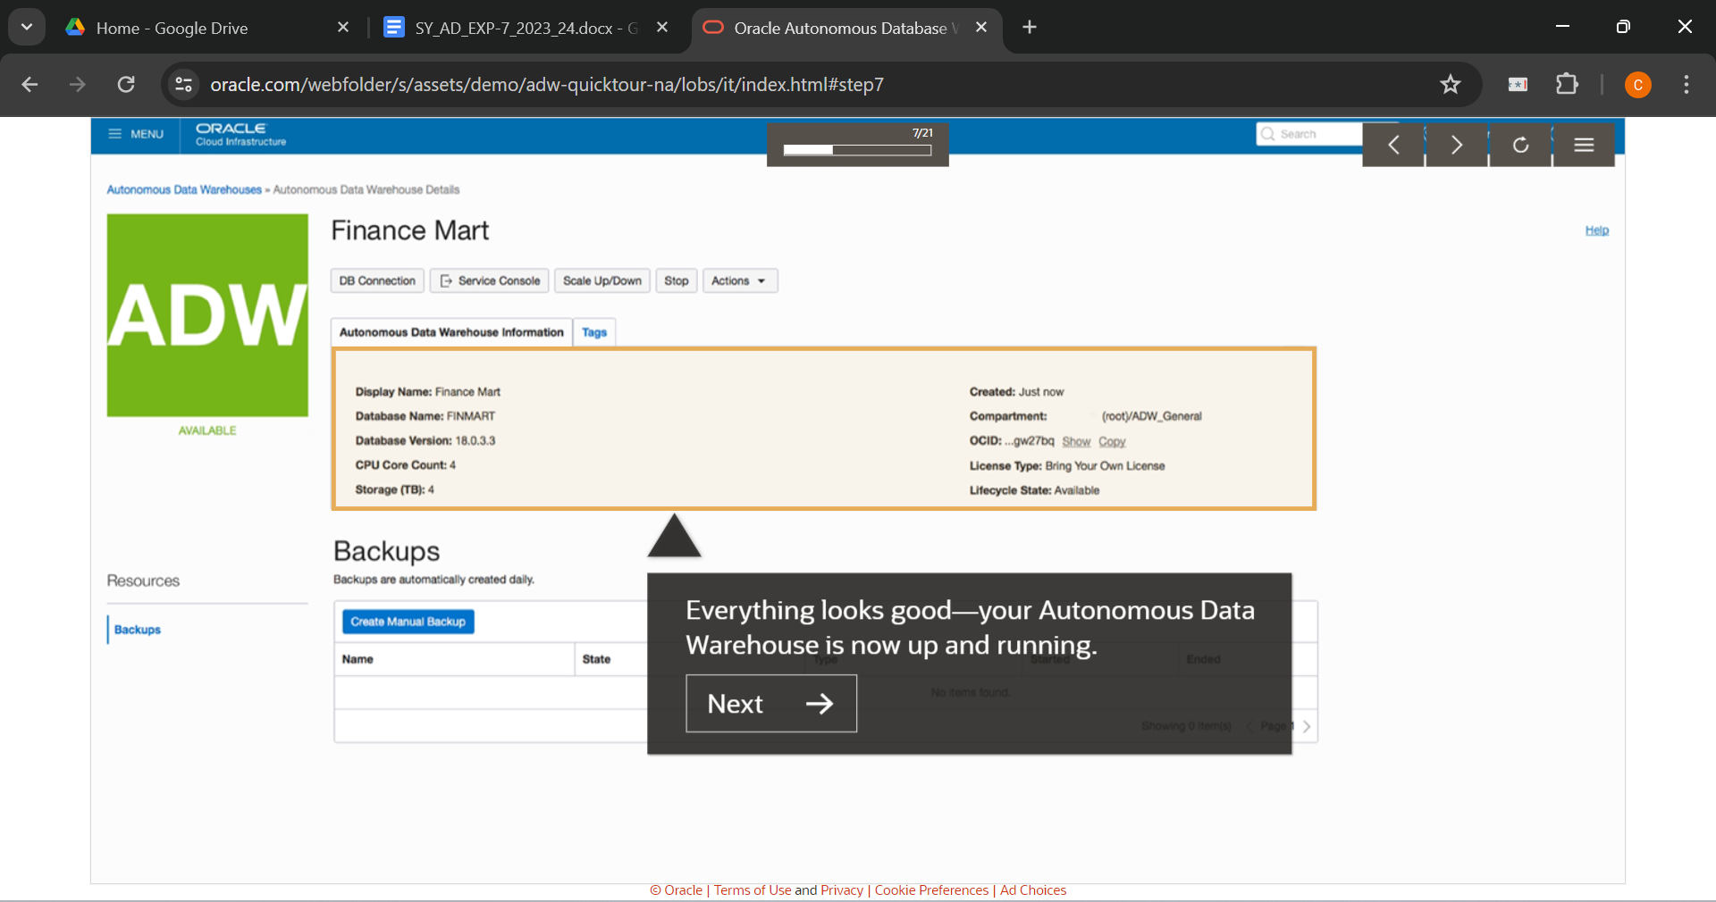

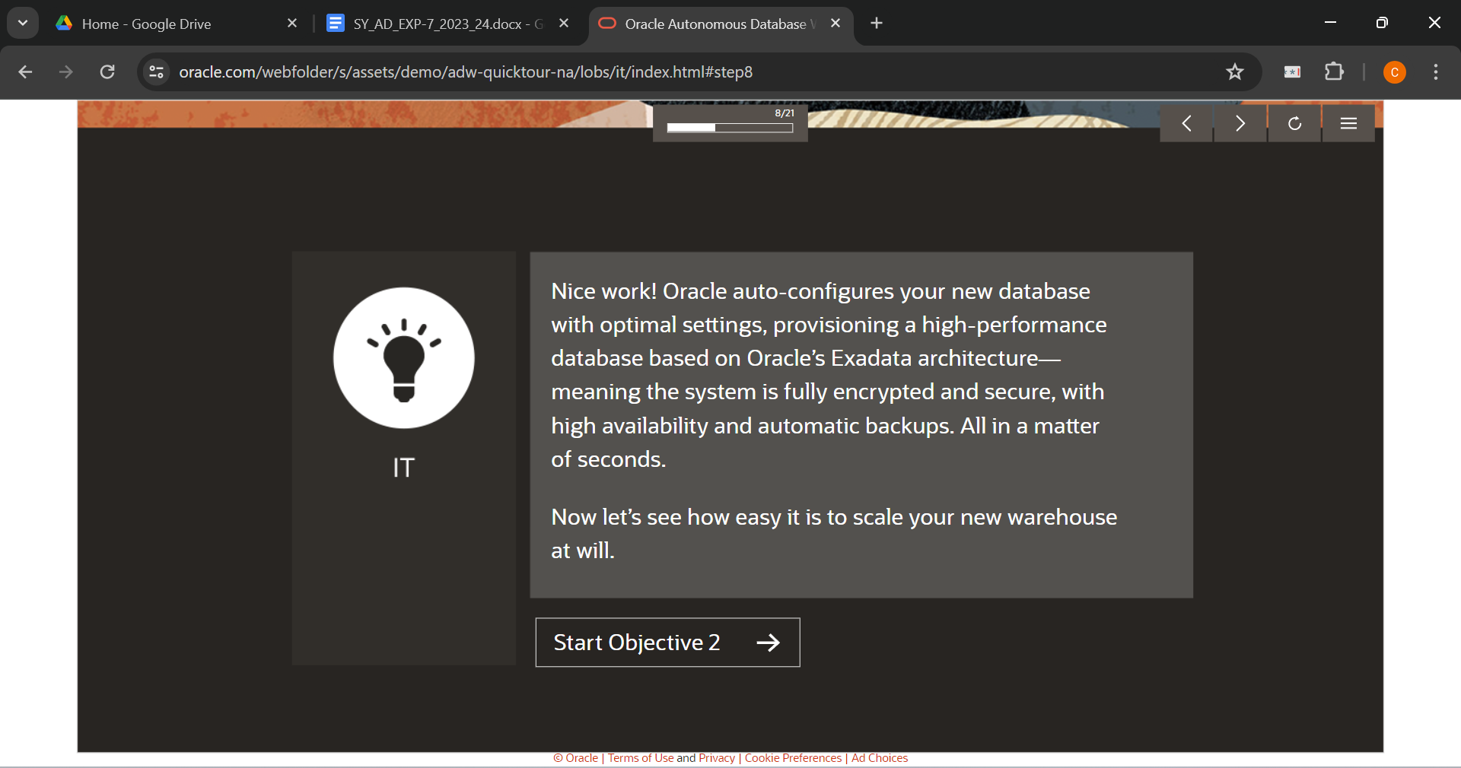

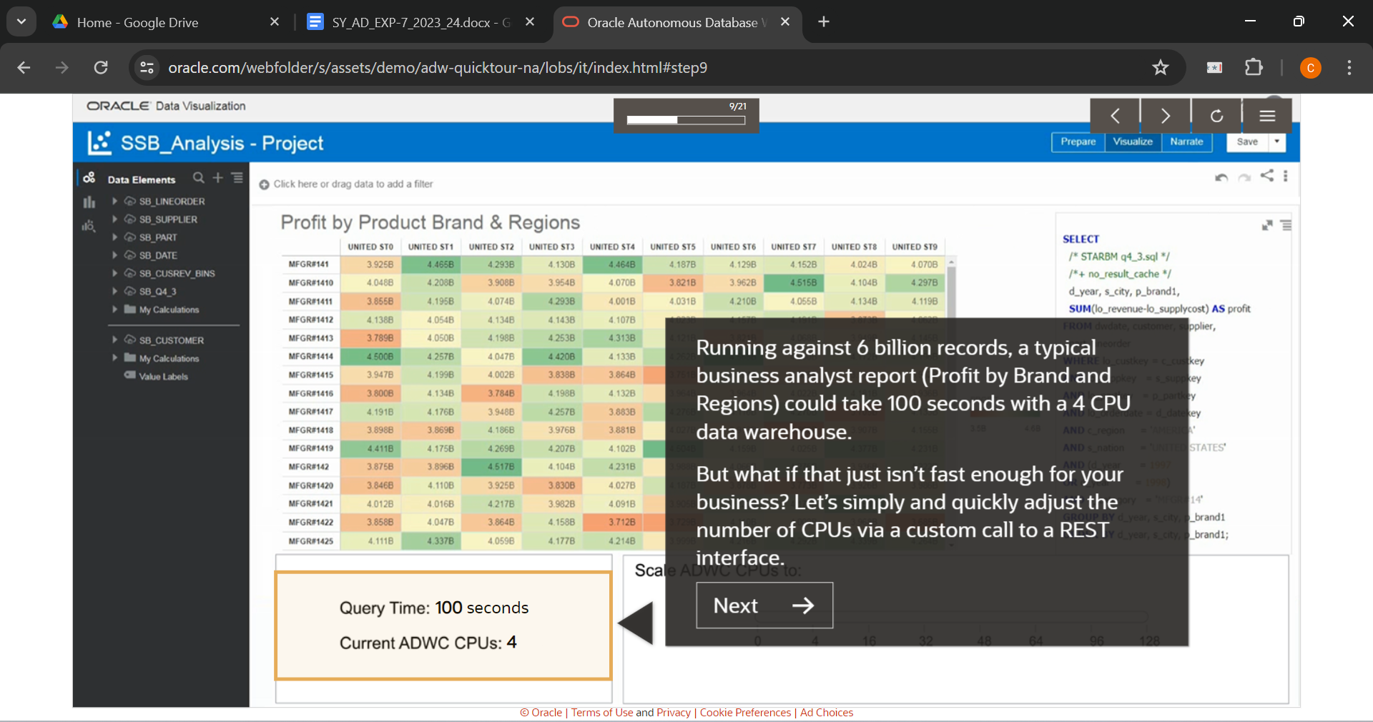

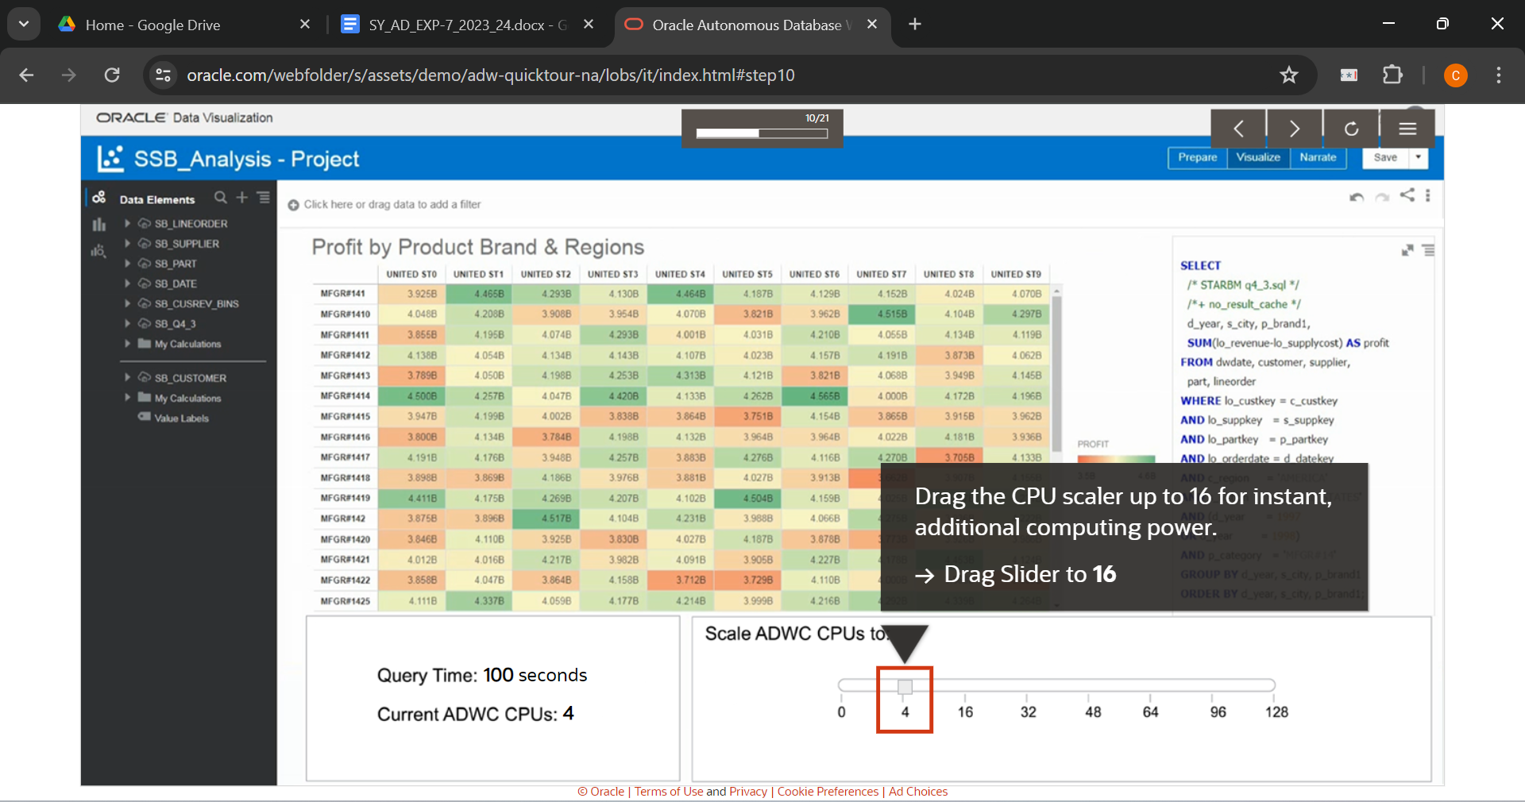

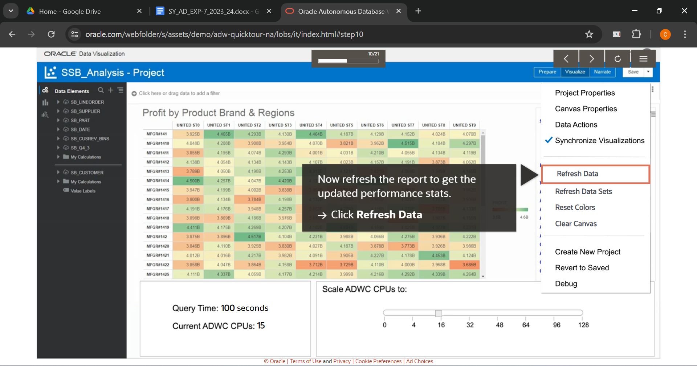

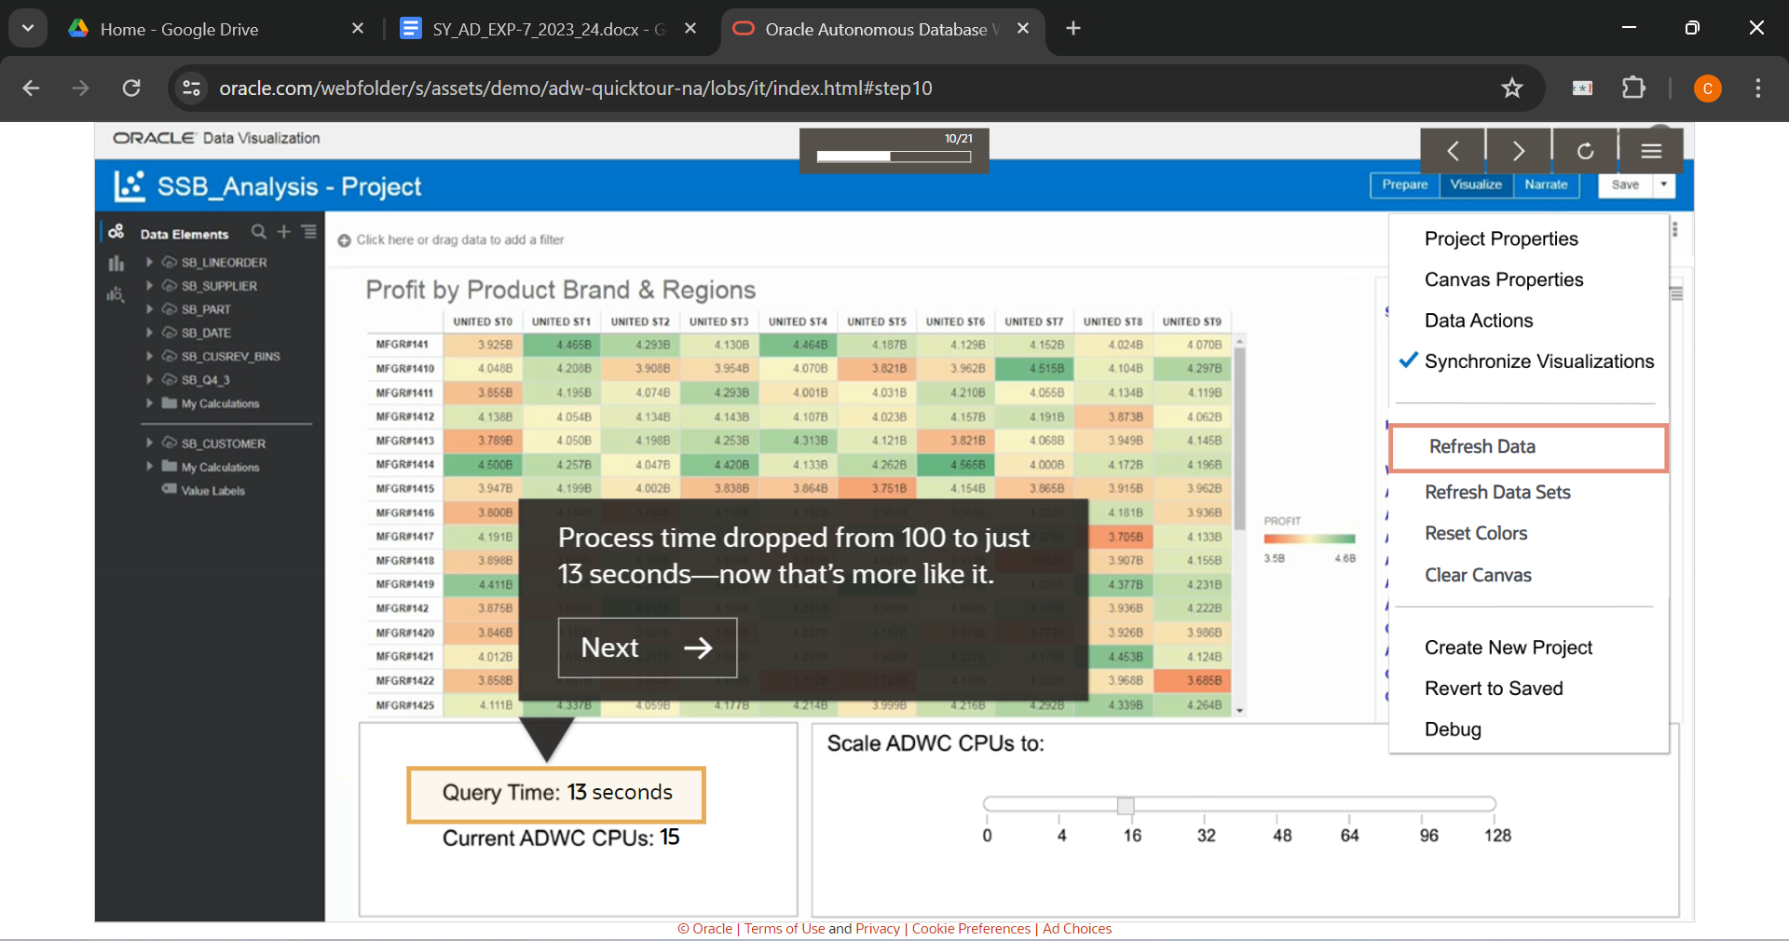

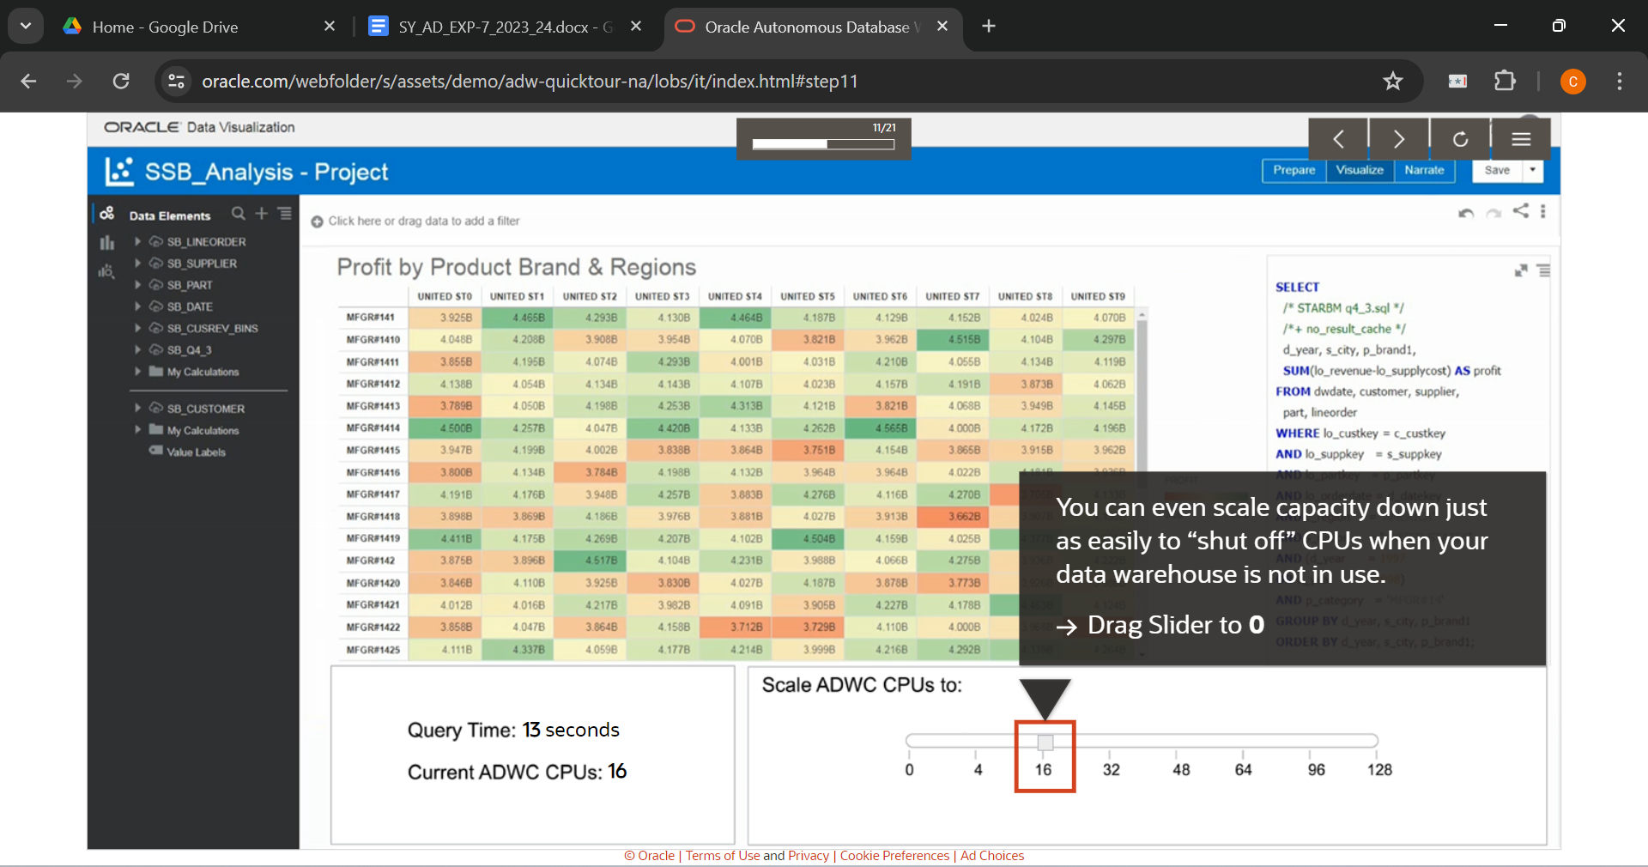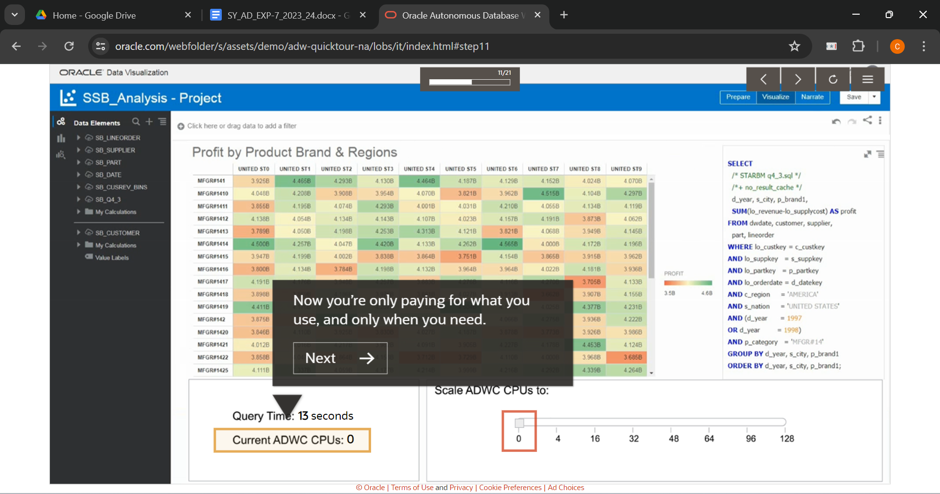

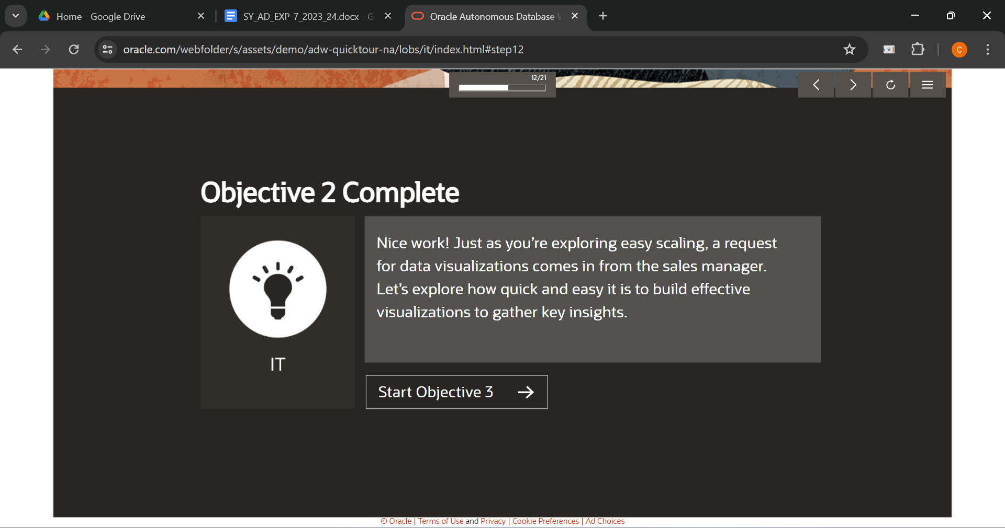

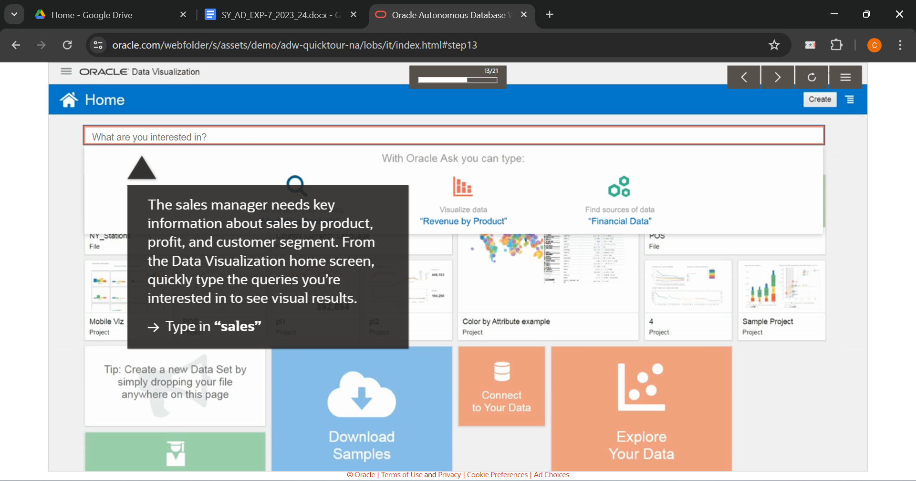

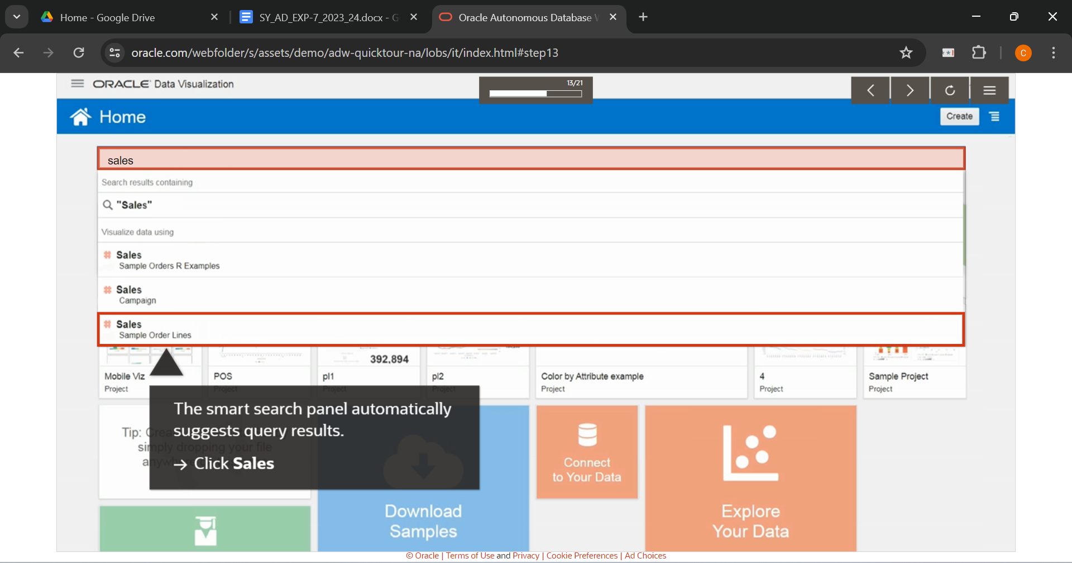

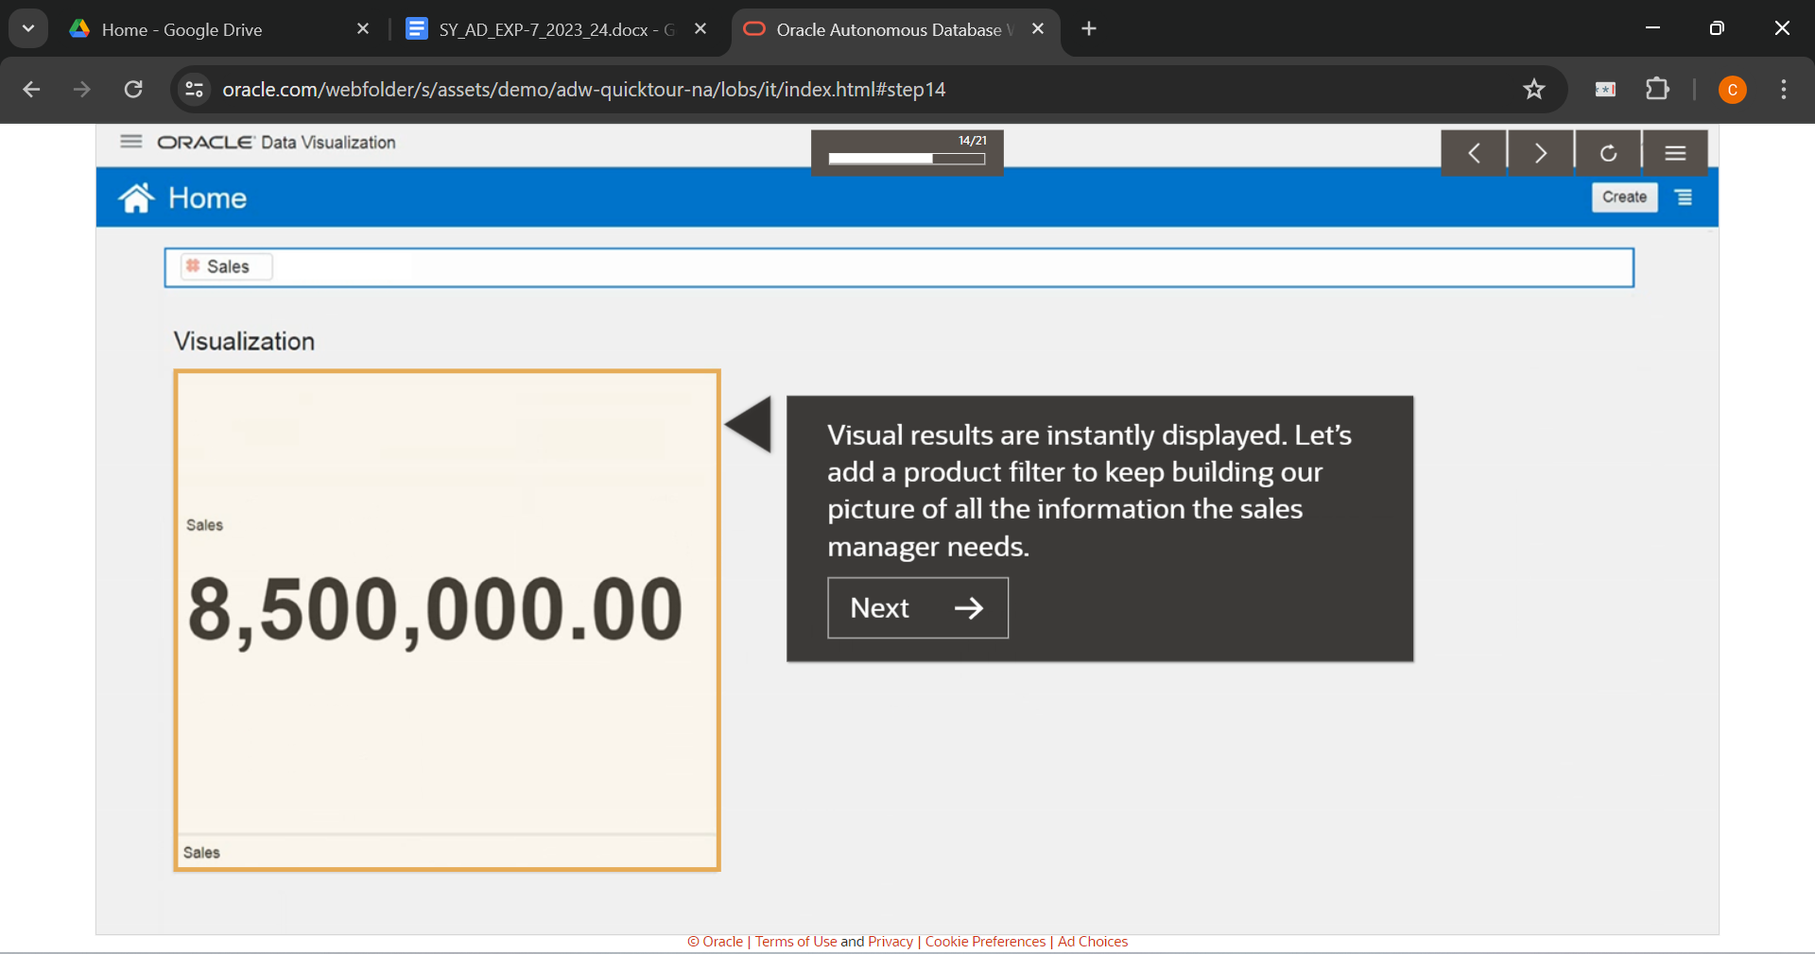

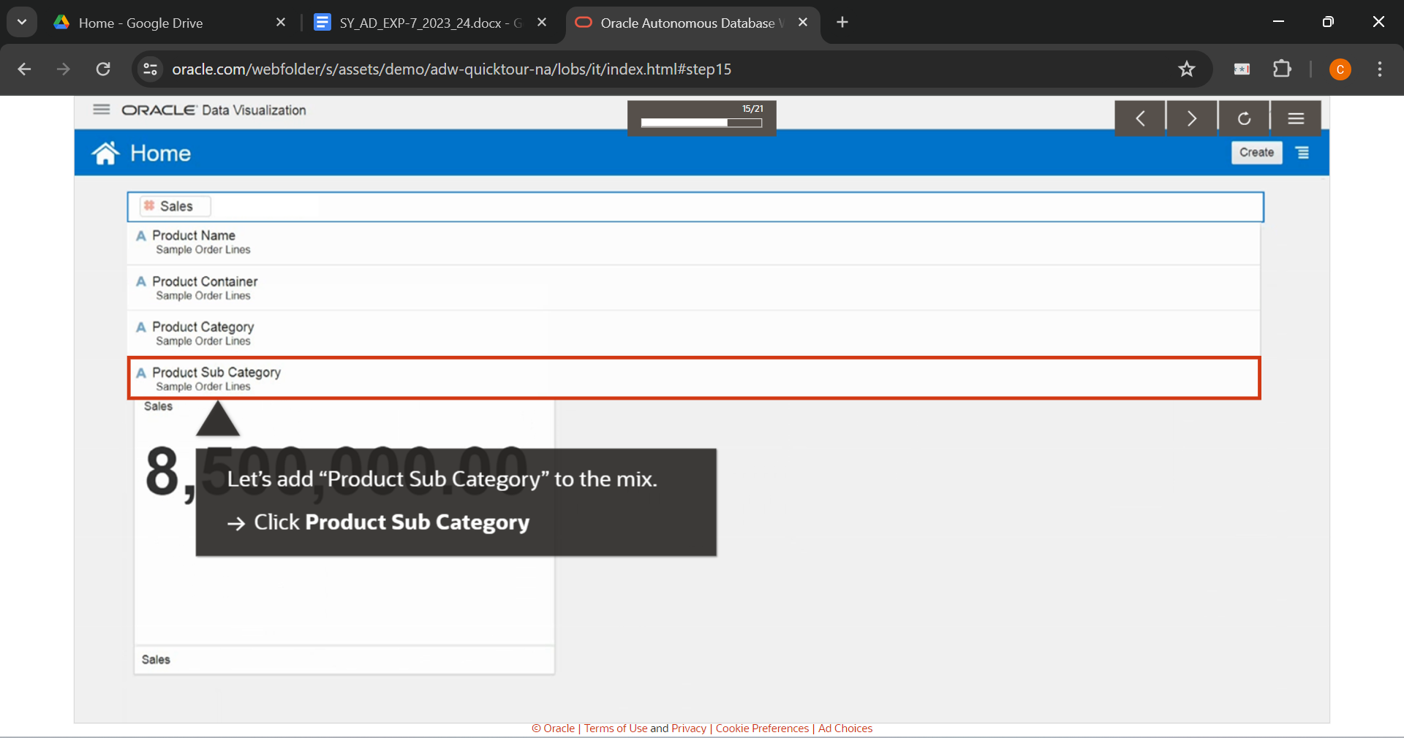

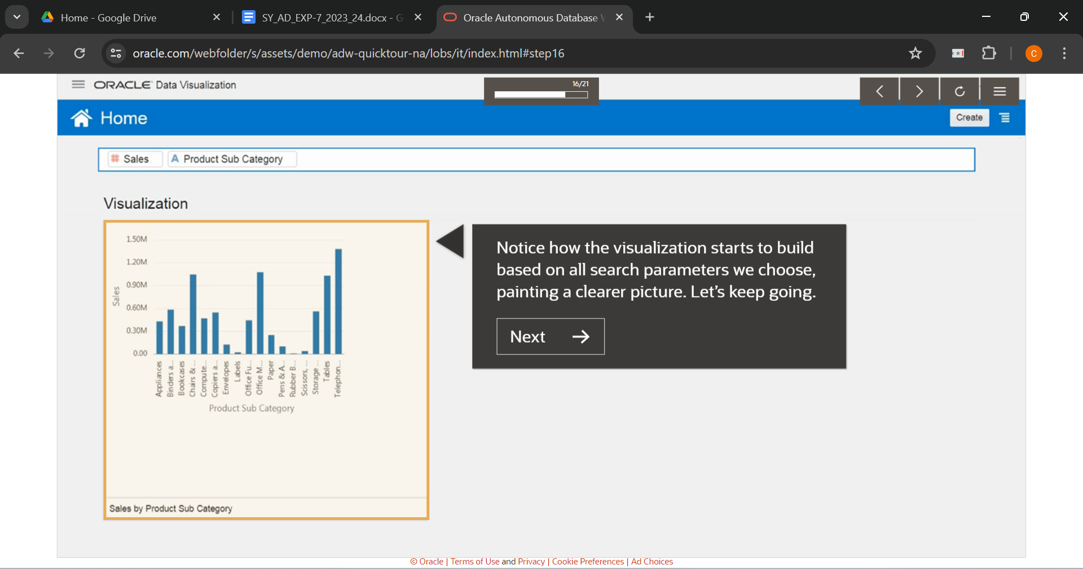

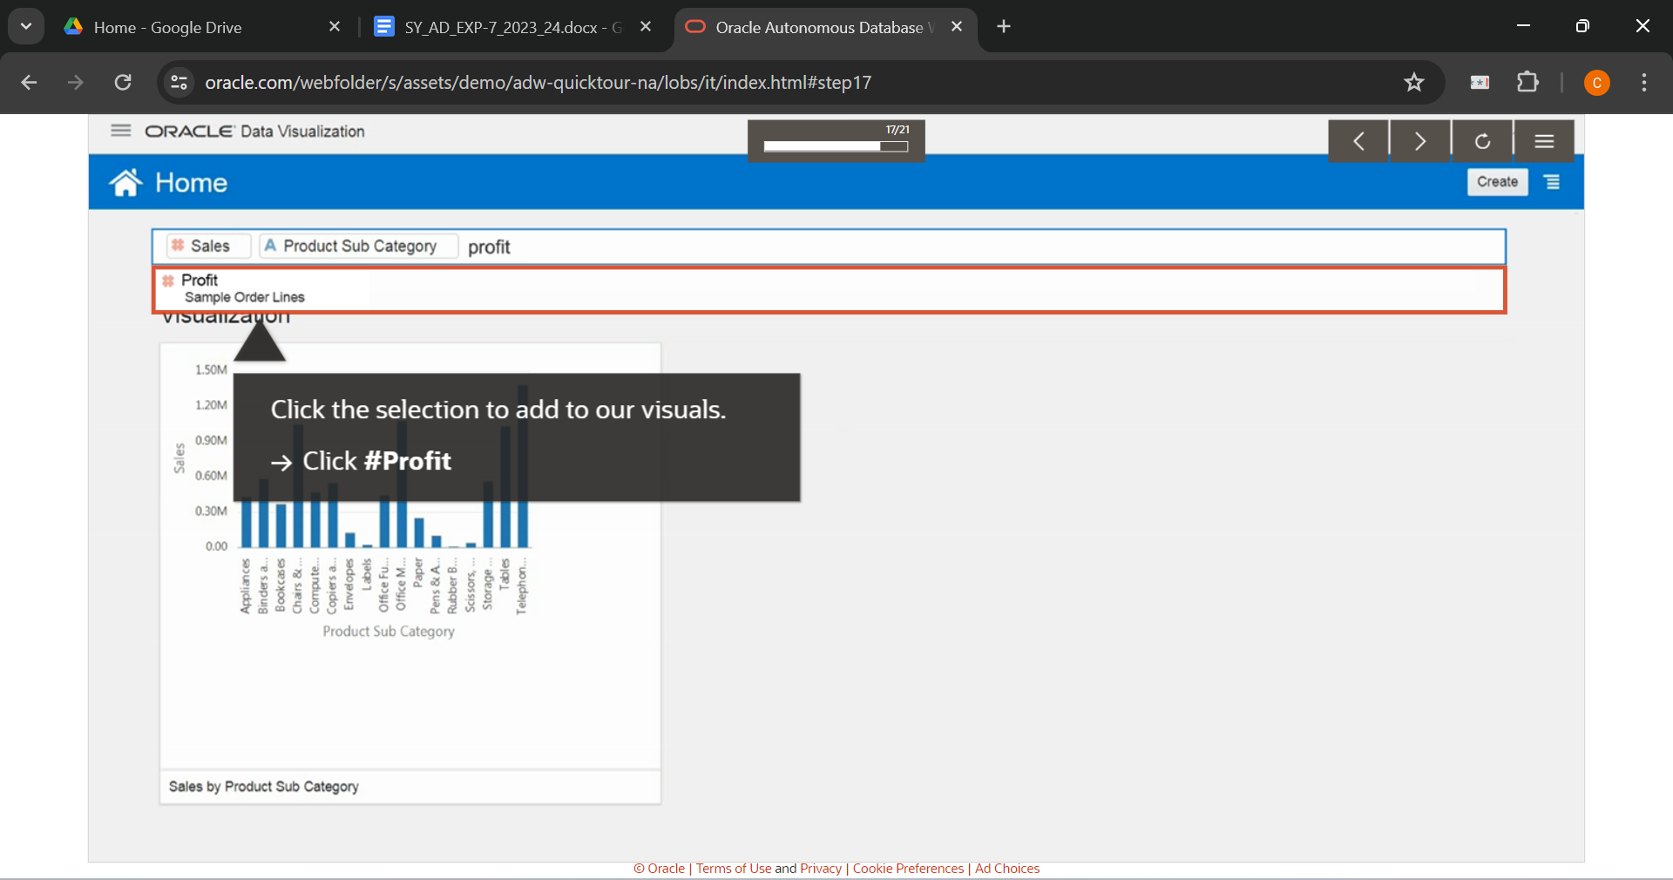

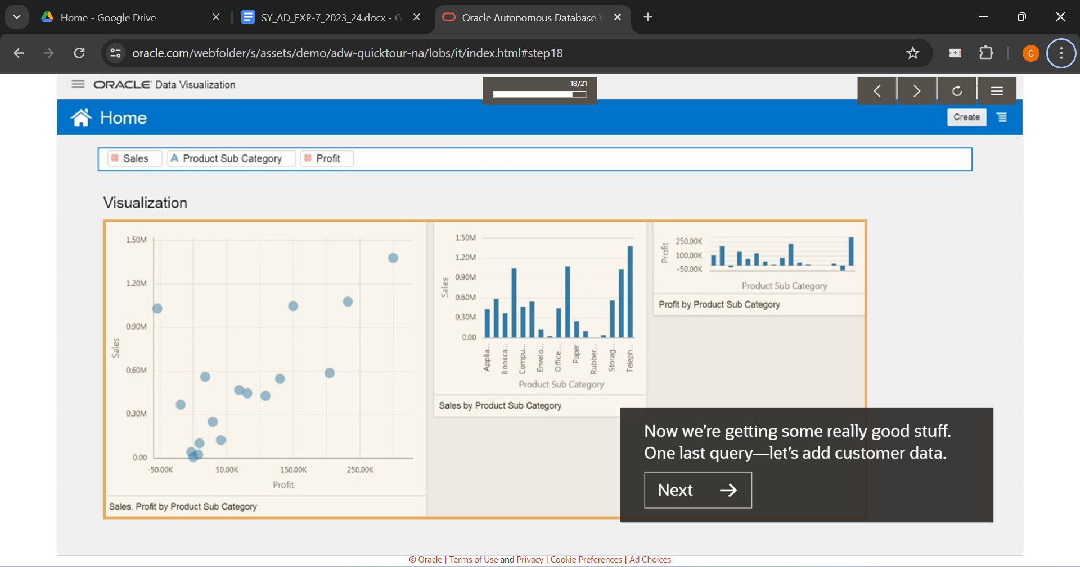

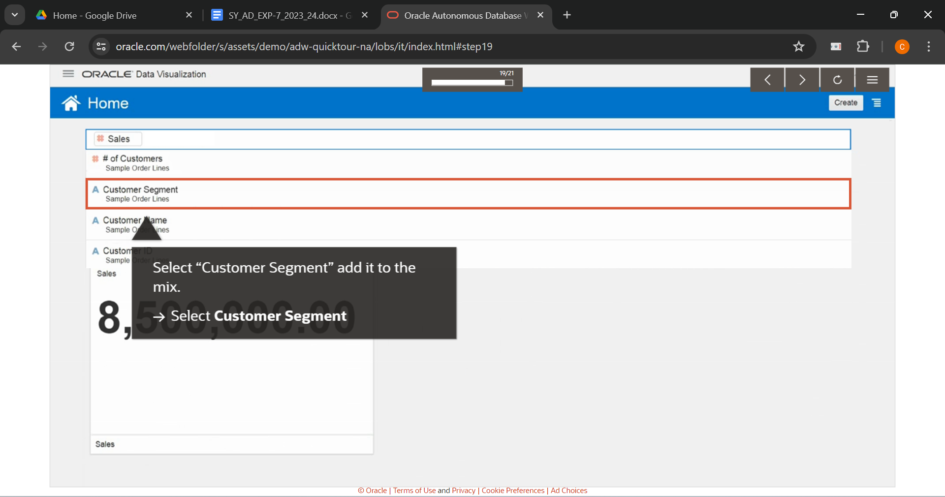

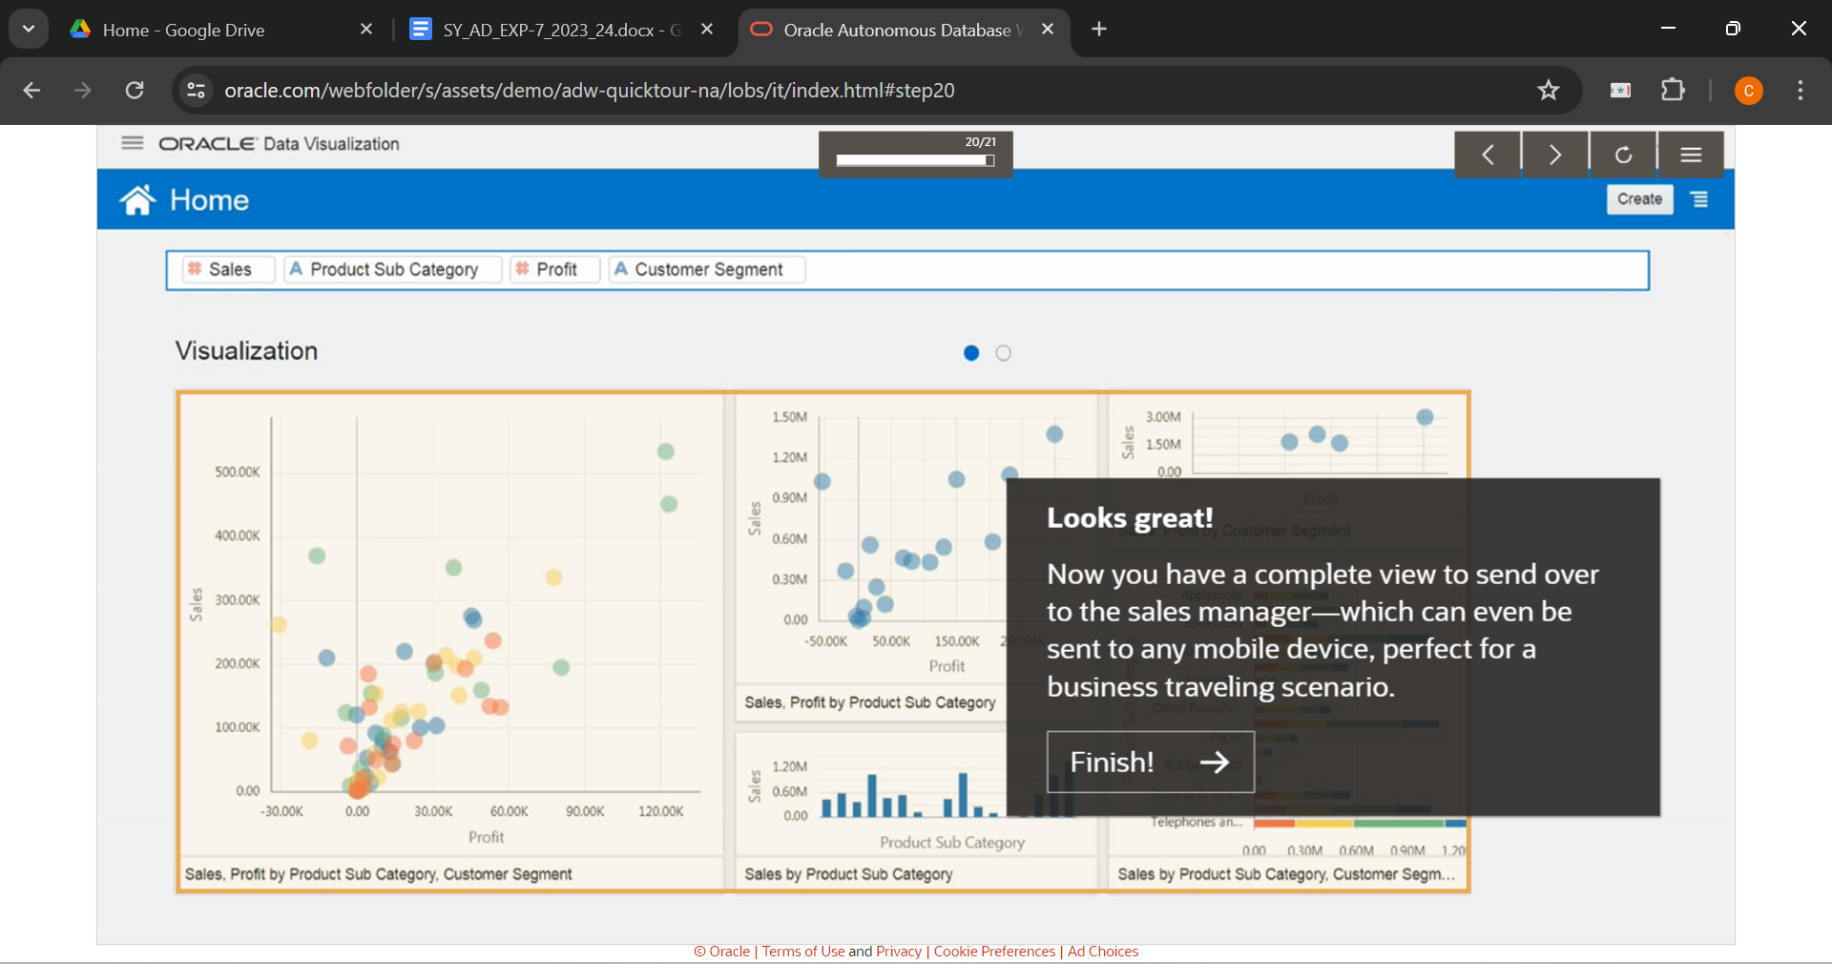

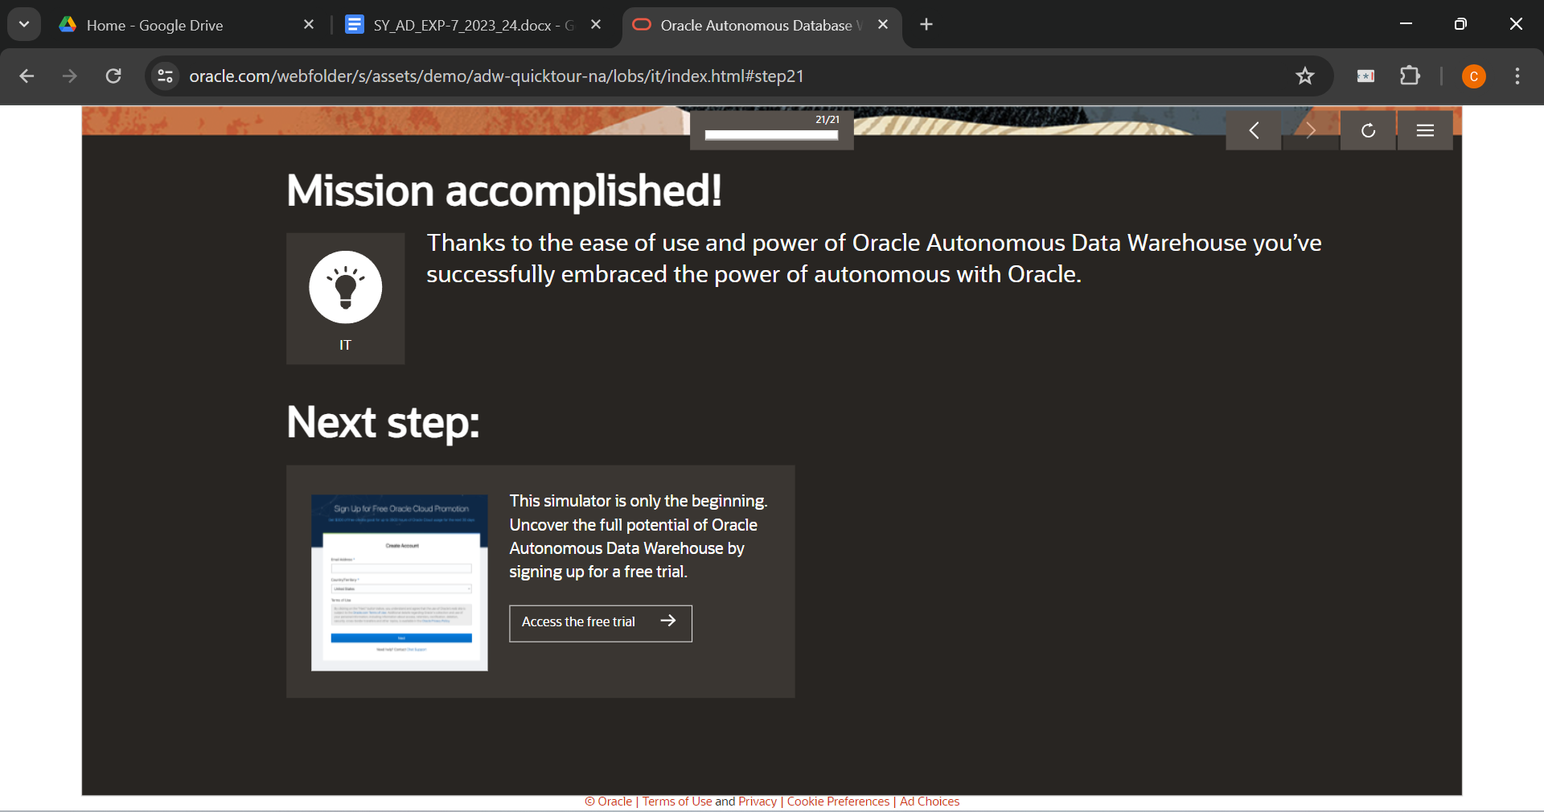

**Report for Data Warehouse**

1. **The nature of analytics for different businesses given**

* Finance: In finance, analytics often involve financial forecasting, risk management, and fraud detection. With Autonomous Data Warehouse (ADW), finance teams can analyze large volumes of historical and real-time financial data to identify trends, anomalies, and potential risks.
* HR: HR analytics encompass employee performance analysis, talent acquisition, and workforce planning. ADW enables HR departments to analyze employee data, such as performance ratings, turnover rates, and demographic information, to optimize recruitment strategies and improve employee retention.
* IT: IT analytics focus on infrastructure performance monitoring, cybersecurity threat detection, and IT service management. ADW provides IT teams with the capability to consolidate and analyze vast amounts of log data, network traffic, and security events to identify potential vulnerabilities and enhance system performance.
* Marketing: Marketing analytics involve customer segmentation, campaign performance analysis, and customer churn prediction. With ADW, marketing teams can analyze customer behavior, purchase history, and demographic data to personalize marketing campaigns, optimize marketing spend, and improve customer engagement.
* Sales: Sales analytics include sales forecasting, customer relationship management, and sales pipeline analysis. ADW empowers sales teams to analyze sales data, such as sales transactions, customer interactions, and sales funnel metrics, to identify cross-selling opportunities, forecast sales revenue, and improve sales performance.

1. **Comparison between traditional analysis and analysis with Data Warehouse**

* Scalability: Traditional analysis often relies on relational databases or spreadsheets, which may struggle to handle large volumes of data. In contrast, ADW offers scalability to process and analyze petabytes of data efficiently.
* Performance: Traditional analysis may suffer from slow query performance and limited processing power, especially when dealing with complex analytical queries. ADW leverages parallel processing and optimization techniques to deliver high-performance analytics, enabling faster decision-making.
* Accessibility: Traditional analysis typically requires manual data extraction, transformation, and loading (ETL) processes, which can be time-consuming and error-prone. ADW automates data ingestion and integration tasks, providing users with real-time access to integrated and cleansed data for analysis.

1. **For any two business type given, specify at least two different scenarios where the tool can be useful**

Finance:

* Scenario 1: Risk Management ADW can analyze historical financial data and market trends to identify potential risks and predict financial market fluctuations, enabling finance professionals to make informed investment decisions.
* Scenario 2: Fraud Detection ADW can analyze transactional data and detect patterns indicative of fraudulent activities, helping finance teams to prevent financial losses and maintain regulatory compliance.

Marketing:

* Scenario 1: Customer Segmentation ADW can analyze customer demographic data, purchase behavior, and interaction history to segment customers based on their preferences and behavior, enabling marketers to tailor marketing campaigns for specific customer segments.
* Scenario 2: Campaign Performance Analysis ADW can analyze campaign engagement metrics, such as click-through rates, conversion rates, and return on investment (ROI), to evaluate the effectiveness of marketing campaigns and optimize marketing spend for maximum impact.

**___________________________________________________________________________**

**Outcomes: Understanding of data warehouse and its multi-dimensional modeling**

**________________________________________________________________________**

**Conclusion: (Conclusion to be based on the outcomes achieved)**

Autonomous Data Warehouse revolutionizes data analytics across diverse industries by offering scalability, speed, cost-effectiveness, and ease of use compared to traditional analysis methods. By leveraging ADW, businesses can unlock valuable insights from their data, drive innovation, and gain a competitive edge in today's data-driven world.

**___________________________________________________________________________**

**Grade: AA / AB / BB / BC / CC / CD /DD**

**Signature of faculty in-charge with date**

**___________________________________________________________________________**

**References:**

* <https://www.oracle.com/in/database/what-is-a-data-warehouse>
* Paulraj Ponniah, “Data Warehousing: Fundamentals for IT Professionals”, Wiley India